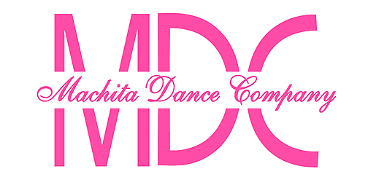  CHECK-IN CARD  Move - Petites  Adkins, Briley  Teacher: Alice G.  Additional Comments  Briley is such a joy to have in class! She follows directions, stays wonderfully on her spot, and picks up ballet and tap steps with ease. | CHECK-IN CARD  Connect - Advanced  Couvillion, Peyton  Teacher: Elise T.  Additional Comments  Always positive and respectful! Keep pushing yourself!
  Skill | Great | Good | Needs work
  Listens to Directions | ✔
  Stays on Spot | ✔
  Class Participation | ✔
  Retention of Skills & Steps | ✔
  Overall Behavior | ✔
  Skill | Great | Good | Needs work
  Focus in Class | ✔
  Body Control/Alignment | ✔
  Flexibility | ✔
  Ability to Pick Up / Remember Choreography | ✔
  Respectfulness | ✔
CHECK-IN CARD  Connect - Advanced  Holmes, Olivia  Teacher: Rayanna B.  Additional Comments  I love you girls so much and you guys make teaching the best!! | CHECK-IN CARD  Connect - Intermediate  Read, Elizabeth Kate  Teacher: Rhylan R.  Additional Comments  Always bringing the best energy to class! Keep it up!
  Skill | Great | Good | Needs work
  Focus in Class | ✔
  Body Control/Alignment | ✔
  Flexibility |  | ✔
  Ability to Pick Up / Remember Choreography | ✔
  Respectfulness | ✔
  Skill | Great | Good | Needs work
  Focus in Class | ✔
  Body Control/Alignment | ✔
  Flexibility | ✔
  Ability to Pick Up / Remember Choreography | ✔
  Respectfulness | ✔

